API

TOP INTERVIEW QUESTIONS

API
Application Programming Interface.
Abstraction of functions of an application to be shared with third parties.

WEB API
It allows sharing functionalities or services that are agnostic and independent of the development language and platform.

ASP.NET Web API
ASP.NET Web API is an .NET framework for building service-oriented RESTful APIs, which can be consumed by other clients such as browsers or mobiles through the HTTP protocol.

SOAP
Simple Object Access Protocol is a standard protocol that defines how two objects in different processes can communicate by exchanging XML data.

XML
Extensible Markup Language (XML) is a markup language and file format for storing, transmitting, and reconstructing arbitrary data

REST
Representational State Transfer.
It’s an architectural style that defines a set of guidelines for building web services.

REST defines 6 architectural constraints – To be a true RESTful API.

Separation of Client–Server
Server request are Stateless
Cacheable request
Uniform interface
Layered system
Code on demand (optional)

RESTFul API
It is the implementation of an API following the REST architecture style.
REST allows to transmit practically any type of data, XML, JSON, Binaries (images, documents), Text. via the HTTP protocol.

HTTP
Hypertext Transfer Protocol (HTTP)
HTTP, protocolo de transferencia utilizado en la web para intercambio de datos.

HTTP CLIENT
The HttpClient class instance acts as a session to send HTTP requests. Provides a base class for sending HTTP requests and receiving HTTP responses from a resource identified by a URI.
HttpClient is intended to be instantiated once per application, rather than per-use.

HTTP METHODS

HTTP METHODS | ACTION | HTTP STATUS SUCCESS | HTTP STATUS FAILURE
GET | Read | 200 | 404 Bad request
POST | Create | 201 | 400 Bad request
PUT | Update/Replace All entity | 204 | 404 Bad request
PATCH | Update/Modify Partial | 204 | 404 Bad request
DELETE | Delete | 204 | 400 Bad request
HEAD | Return metadata

HTTP CODE STATUS
Responses are grouped in five classes:

1. Informational (100–199)
2. Successful (200–299)
3. Redirection (300–399)
4. Client errors (400–499)
5. Server errors (500–599)

HTTP CODE STATUS MOST COMMON
200 - Success.
201 - Created.
301 - Permanent Redirect.
400 - Bad request. Data issues such as invalid JSON, etc.
401- Unauthorized.
403 – Forbidden: The user is trying to access a resource they can’t have access to.
404 - Not found. Resource not found on GET.
410 - Gone
500 - Internal Server Error
503 - Service Unavailable

Endpoint:
URL (Uniform Resource Locator) that our HTTP requests are sent to. Are defined by nouns no by verbs.
API endpoint: /api/categories

Serialize vs Deserialize
Serialization refers to the process of converting an object or data structure into a format that can be stored or transmitted. This is typically done by converting the object into a stream of bytes or a text-based format like JSON or XML.

Deserialization, on the other hand, is the process of converting serialized data back into an object or data structure that can be used by the application.

URI vs URL
A URI (Uniform Resource Identifier) is an identifier of a specific resource. Like a page, or book, or a document.
A URL (Uniform Resource Locator) is a special type of identifier that also tells you how to access it, such as HTTPs, FTP, etc. like https://www.google.com.
All URLs are URIs, but not all URIs are URLs.

Web API vs WCF
WCF (Windows Communication Foundation): It is a framework used for developing SOAP (Service-oriented applications).

Web API: It is an application programming interface for both web browsers and web servers.

REST API vs RESTful API
REST (Representation State Transfer) API It is basically an architectural style that makes productive use of existing technology and protocols of the web. It is a set of rules that developers need to follow when they develop their API or services that are scalable. It is used with HTTP protocol using its verbs such as GET, DELETE, POST, PUT.
RESTful API: It is simply referred to as web services executing such as architecture.

Minimal APIs vs controller-based APIs
Minimal APIs offer a short syntax to create HTTP handlers for all HTTP methods. They are ideal for microservices and apps that want to include only the minimum files, features, and dependencies in ASP.NET Core.

What is XML and JSON?
XML (Extensible Markup Language):
- It is especially designed to store and transport data.
- It is similar to HTML but is more flexible than HTML because it allows users to create their own custom tags.
- It is used for representing structured information such as documents, data, configuration, etc.

JSON (JavaScript Object Notation):
- It is a lightweight format designed to store and transport data.
- It is easier to understand and is a standard text-based format used for representing structured data based on JavaScript object syntax.
- It is faster and easier to use.

Idempotency in REST
Operation that can be applied several times without changing the result.
GET / PUT / PATCH / DELETE

POST is not Idempotent

Stateless vs Stateful

In summary, stateless systems or applications do not keep track of user data, while stateful systems do keep track of user data and maintain the state from one request to the next.

Design API
Associated resources
Are related concepts that allow you to go deeper to get data.
/api/customers/101/invoice
http://arest.me/api/regions/africa/sites
Paging
List should allow paging and query string is the most used.
http://arest.me/sites/?page=2

Error Handling
Return error code and some text info for the user or developer to understand why the error.

Caching
Caching with ETags

Validating
Validate the request with attributes

Functional APIs
Should be the exception.
api/restartServer?isColdBoot=true
api/calculateTax?state=GA&total=149.99

Async APIs
Some Async APIs solutions =>
Comet / gRPC/ SignalR / Firebase / Socket.IO

Versioning
Some versioning types are =>
Versioning in the URI Path
https://foo.org/api/v2/Customers

Versioning with Query String
https://foo.org/api/Customers?v=2.0

Versioning with Headers
X-Version: 2.0

Versioning with Accept Header
Accept: application/json;version=2.0

Security
Cross Domain Security
Cross Origin Resource Sharing (CORS)
Authentication => Who you are
Authentication Types for APIs
Cookies / Basic Auth / Token Auth / OAuth
Authorization => What you can do

Swagger
Swagger is basically a description language that is used for the description of RESTful API. It is open-source software.

Postman
Postman is computer software that was built with the purpose of creating and testing API’s. Using postman request can be made to the server and the response can be received.

GraphQL
GraphQL is a query language for APIs. GraphQL provides a complete and understandable description of the data in your API, gives clients the power to ask for exactly what they need and nothing more.
While typical REST APIs require loading from multiple URLs, GraphQL APIs get all the data your app needs in a single request. Apps using GraphQL can be quick even on slow mobile network connections.

gRPC
gRPC is a robust open-source RPC (Remote Procedure Call) framework used to build scalable and fast APIs. It allows the client and server applications to communicate transparently and develop connected systems.

Middleware
Middleware is software that enables one or more kinds of communication or connectivity between applications or application components in a distributed network.

JSONPatch

API Questions

What are Web API filters?
Filters are basically used to add extra logic at different levels of Web API framework request processing. Different types of Web API filters are available as given below:
- Authentication Filter: It handles authentication and authenticates HTTP requests. It also helps to authenticate user detail. It checks the identity of the user.
- Authorization Filter: It handles authorization. It runs before controller action. This filter is used to check whether or not a user is authenticated. If the user is not authenticated, then it returns an HTTP status code 401 without invoking the action.
- AuthorizeAttribute is a built-in authorization filter provided by Web API.
- Action Filter: It is attributing that one can apply to controller action or entire controller. It is used to add extra logic before or after controller action executes. It is simply a way to add extra functionality to Web API services.
- Exception Filter: It is used to handle exceptions that are unhandled in Web API. It is used whenever controller actions throw an unhandled exception that is not HttpResponseException. It will implement an “IExceptionFilter” interface.
- Override Filter: It is used to exclude specific action methods or controllers from the global filter or controller level filter. It is simply used to modify the behavior of other filters for individual action methods.

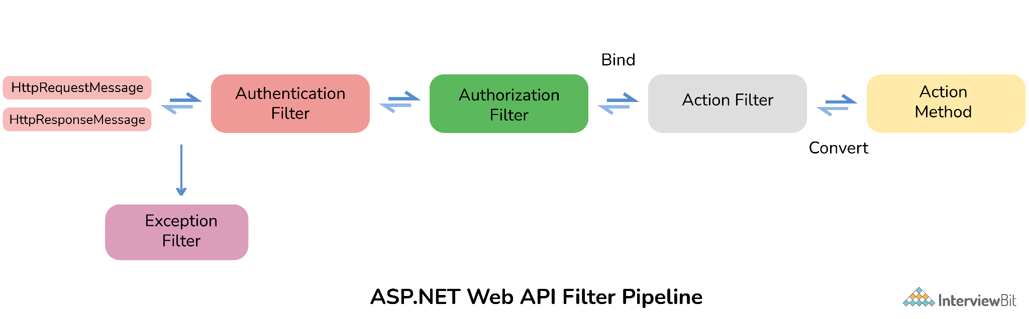

HOW to secure ASP.NET Web API?
Web API has become key to programming web-based interactions. It can be accessed by anyone who knows the URL. Therefore, they have become targets for hackers. One needs to secure Web API by controlling Web API and by deciding who can and who cannot have access to Web API. There are basically two ways or techniques that make our Web API more secure.

Authentication: It is a process that helps to identify and check users by their credentials such as password, username, etc. To have access to the web API, firstly user credentials are needed to be passed in the request header. If user credentials are not passed into the request header, then the server returns 401 status code (unauthorized). The best authentication to be used is OAuth 2.0.

Authorization: It is a process that helps to decide whether or not a user has access to perform an action. Authorization filters are used to implement authorization.

What do you mean by Caching and What are its types
Caching is basically a technique or process of storing data somewhere or in the cache for future requests. The cache is a temporary storage area.

Advantages of Caching:
- It is considered the best solution to ensure efficiency.
- It delivers web objects faster to the end-user.
- It reduces load time on the website server.
- It leads to faster execution of any process.
- It decreases network costs.
Types of Caching:
There are basically three types of caching as given below:
- Page Caching
- Data Caching
- Fragment Caching

What are the main return types supported in Web API?
It can return data of any type depending upon the business requirement. There are many HTTP methods like GET, POST, PUT, etc., which can return data in different formats.

Types of API design patterns
Following are some of the commonly used API design patterns:
RESTful API:
- Uses HTTP methods to interact with resources
RPC API:
- Uses Remote Procedure Calls to interact with a remote server
GraphQL API:
- Allows clients to request exactly the data they need

4. SOAP API:
- Uses a messaging protocol to exchange structured information

5. Hypermedia API:
- Includes links between resources, allowing for dynamic discovery and navigation

6. Event-driven API:
- Sends notifications to clients when certain events occur

7. Message Queue API:
- Allows applications to send and receive messages asynchronously

